

**KOI VETERINARY SERVICE CENTER**

**Software Requirement Document**

**Report 3 - User Requirements**

– HoChiMinh, October 2024 –

**Table of Contents**

Record of Changes 3

III. User Requirements 4

1. Actors 4

2. Use Cases 5

2.1 Diagram 5

2.2 Descriptions 5

3. Business Rules 10

# Record of Changes

| **Date** | **A* M, D** | **In charge** | **Change Description** |
| --- | --- | --- | --- |
|  |  |  |  |
|  |  |  |  |
|  |  |  |  |
|  |  |  |  |
|  |  |  |  |
|  |  |  |  |
|  |  |  |  |
|  |  |  |  |
|  |  |  |  |
|  |  |  |  |
|  |  |  |  |
|  |  |  |  |
|  |  |  |  |

*A - Added M - Modified D - Deleted

# III. User Requirements

## 1. Actors

| **#** | **Actor** | **Description** |
| --- | --- | --- |
| 1 | Guest | Unregistered users who visit the system to browse general information about the Koi Veterinary Service Center. Guests can view the homepage, read about services, news, FAQs, and contact details but cannot book any services without registering. |
| 2 | Customer | Registered users who have the ability to book services such as consultations, treatments, and on-site evaluations. They can also provide feedback and ratings after receiving services and can view their booking history |
| 3 | Staff | Administrative employees responsible for handling customer inquiries, managing service bookings, and assigning veterinarians to tasks. Staff ensure that customers' appointments are correctly scheduled and that the necessary resources are available. |
| 4 | Veterinarian | Professionals responsible for providing the actual veterinary services, including consultations, treatments, and on-site evaluations. Veterinarians update service records, provide medical advice, prescribe medication, and document outcomes after service. |
| 5 | Manager | Oversees the entire system, including staff and veterinarians. The manager ensures smooth operation, manages service pricing, monitors feedback and ratings, and generates reports for performance and service analytics. |

## 2. Use Cases

### 2.1 Diagram

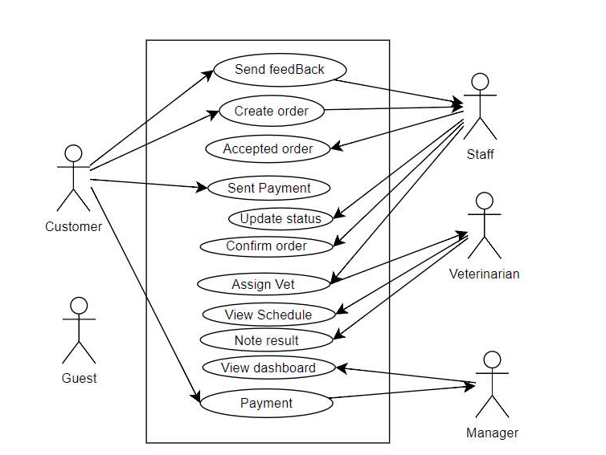

### 2.2 Descriptions

| **ID** | **Use Case** | **Actors** | **Use Case Description** |
| --- | --- | --- | --- |
| UC-01 | Book a Service | Customer  Staff | Customer selects a service (consultation, evaluation, treatment), books an appointment, pays a deposit, and receives the service. Staff manages the appointment and assigns the veterinarian​ |
| UC-02 | Provide Feedback | Customer  Staff | After receiving a service, the customer submits feedback and rates the veterinarian. The staff processes the feedback and manages it accordingly​ |
| UC-03 | Assign Veterinarian | Staff  Veterinarian | Staff assigns a veterinarian to the customer’s appointment based on availability or customer preference. The veterinarian views their schedule and provides the service |
| UC-04 | View Appointment History |  | Customer views the history of past appointments, including consultation details, results, and service history​ |

| ID and Name: | **UC-01 Book a Service** | | |
| --- | --- | --- | --- |
| Created By: | Group4 | Date Created: |  |
| Primary Actor: | Customer | Secondary Actors: | Staff, Veterinarian |
| Description: | The customer selects a service (such as a health consultation, pond evaluation, or fish disease treatment) either at home or at the veterinary center. The customer books the service, confirms the appointment, makes a payment, and proceeds to the service. Staff assigns veterinarians, manages the appointments, and ensures the resources are available. | | |
| Trigger: | The customer decides to book a veterinary service for their Koi fish through the system. | | |
| Preconditions: | PRE-1: The customer must be logged into the system.  PRE-2: The selected service must be available.  PRE-3: The veterinarian must have availability during the requested time. | | |
| Postconditions: | POST-1: The customer’s appointment is confirmed and stored in the system.  POST-2: The payment is processed and marked as received.  POST-3: The assigned veterinarian is notified of the scheduled service and the customer is notified of the appointment details. | | |
| Normal Flow: | 1. Customer selects a service   * The customer navigates to the "Services" section and selects a desired service.   2. Customer chooses appointment time   * The system displays available appointment slots based on veterinarian availability. * The customer selects a preferred date and time.   3. Customer reviews and confirms details   * The system shows a summary of the service details, including the selected veterinarian (if applicable), service date, time, and pricing. * The customer reviews and confirms the appointment details.   4. Customer makes a payment   * The system prompts the customer to pay a deposit (or full payment) to secure the appointment. * The customer completes the payment using an integrated payment gateway. * The system processes the payment and updates the order status to "Confirmed."   **5.** Veterinarian assigned (if needed)   * If the customer hasn’t chosen a specific veterinarian, Staff assigns one based on availability. * The assigned veterinarian’s schedule is updated with the new appointment.   6. Confirmation sent   * The system sends a confirmation notification to the customer via email containing appointment details. * The veterinarian is also notified of the upcoming appointment. | | |
| Alternative Flows: | AF-1: Customer cancels before payment   * If the customer changes their mind before confirming the payment, they can cancel the booking without penalty.   AF-2: Payment failure   * If the payment fails, the system notifies the customer to retry the payment or cancel the booking. * If the payment is not completed within 2 hours, the appointment is automatically cancelled, and the customer is notified. | | |
| Exceptions: | E-1: Appointment cancellation due to veterinarian unavailability   * In case the assigned veterinarian becomes unavailable (due to emergency, etc.), the system sends a notification to the customer offering alternative slots or another veterinarian.   E-2: No veterinarian available   * Customer can not order if no veterinarians are available at the chosen time | | |
| Priority: | High | | |
| Frequency of Use: | The use case is expected to be executed frequently by Koi fish owners, especially during peak service seasons or during promotional periods. | | |
| Business Rules: | **BR-01, BR-02, BR-03, BR-04** | | |
| Other Information: | * Veterinarians will receive their updated schedules in real-time and can view any new assignments through their profile page​ * Customers should be able to modify or cancel the appointment up to 2 hours before the scheduled time. | | |
| Assumptions: | * Assume that veterinarian schedules are efficiently managed and updated in real-time. * Assume that the payment system uses robust security measures for transactions. | | |

| ID and Name: | **UC-02 Provide Feedback** | | |
| --- | --- | --- | --- |
| Created By: | Group 4 | Date Created: |  |
| Primary Actor: | Customer | Secondary Actors: | Staff, Manager |
| Description: | This use case allows customers to submit feedback after receiving a service. The feedback is stored in the system and processed by the staff to improve service quality. Customers can also rate veterinarians based on the quality of care provided | | |
| Trigger: | The customer completes a service and decides to provide feedback. | | |
| Preconditions: | PRE-1: The service must be completed.  PRE-2: The customer must be logged into the system. | | |
| Postconditions: | POST-1: The feedback is stored in the system.  POST-2: The staff reviews and processes the feedback | | |
| Normal Flow: | 1. Customer views appointment history   * The customer logs into the system and navigates to the "Appointment History" section.   2. Customer provides feedback   * The customer selects a past appointment and submits feedback, including ratings for the veterinarian or the service itself.   3. Staff processes feedback   * The staff receives the feedback and takes appropriate action, such as flagging issues for investigation or marking it as reviewed. | | |
| Alternative Flows: | None | | |
| Exceptions: | E-1: Service not completed   * If the service was not completed (e.g., the customer cancelled it), the feedback form will not be available for submission. | | |
| Priority: | Medium | | |
| Frequency of Use: | This use case will be executed by customers after receiving services. | | |
| Business Rules: | BR-05, BR-06 | | |
| Other Information: | * Staff can also mange feedback of customer reviews * Staff can generate a report and give it to Manager to manage internal processes | | |
| Assumptions: | * Assume that customers are encouraged to provide feedback after every appointment. * Assume that staff review all feedback within 48 hours | | |

| ID and Name: | **UC-03 Assign Veterinarian** | | |
| --- | --- | --- | --- |
| Created By: | Group4 | Date Created: |  |
| Primary Actor: | Staff | Secondary Actors: | Veterinarian |
| Description: | This use case allows staff to assign veterinarians to customer appointments based on availability or customer preference. The system updates the veterinarian’s schedule automatically, and the veterinarian is notified of the upcoming service. | | |
| Trigger: | A customer books a service. | | |
| Preconditions: | PRE-1: A service has been booked and confirmed.  PRE-2: Veterinarians have availability during the requested time. | | |
| Postconditions: | POST-1: ifThe veterinarian is assigned to the service.  POST-2: The appointment is added to the veterinarian’s schedule | | |
| Normal Flow: | 1. Staff reviews appointment request   * Staff logs into the system and views the list of upcoming customer appointments.   **2.** Staff assigns a veterinarian   * Based on availability, the staff assigns a veterinarian to the service.   3. Veterinarian is notified   * The system updates the veterinarian’s schedule, and a notification is sent to the veterinarian about the assigned appointment.   4. Confirmation sent to customer   * The system confirms the veterinarian assignment to the customer. | | |
| Alternative Flows: | **AF-1: Customer selects veterinarian**   * If the customer selects a veterinarian during booking, the staff simply confirms the assignment. | | |
| Exceptions: | None | | |
| Priority: | High | | |
| Frequency of Use: | This use case will be executed frequently as staff assign veterinarians to appointments | | |
| Business Rules: | **BR-07, BR-08** | | |
| Other Information: | * The system ensures that veterinarians are notified in real-time of new appointments | | |
| Assumptions: | * Assume that veterinarians’ schedules are accurately updated in real time | | |

| ID and Name: | **UC-04: View Appointment History** | | |
| --- | --- | --- | --- |
| Created By: | Group4 | Date Created: |  |
| Primary Actor: | Customer | Secondary Actors: | Staff |
| Description: | This use case allows customers to view their past appointments, including details such as service type, veterinarian information, and consultation results. Customers can also view and download service reports. | | |
| Trigger: | The customer decides to view past appointments. | | |
| Preconditions: | PRE-1: The customer must be logged into the system.  PRE-2: The customer must have completed at least one appointment. | | |
| Postconditions: | POST-1: The appointment history is displayed, including all relevant details. | | |
| Normal Flow: | 1. Customer logs in   * The customer logs into the system and navigates to the "Appointment History" section.   2. Customer views appointment history   * The system displays a list of past appointments, including service details, results, and veterinarian information.   3. Customer views individual appointment details   * The customer selects an individual appointment to view further details, including feedback and consultation results. | | |
| Alternative Flows: | AF-1: No past appointments   * If the customer has no past appointments, the system displays a message indicating no available history. | | |
| Exceptions: | E-1: Data retrieval error   * If the system cannot retrieve appointment data due to a technical issue, the customer is notified, and the system logs the error. | | |
| Priority: | Medium | | |
| Frequency of Use: | Customers are expected to view their appointment history regularly, especially to review service outcomes or feedback | | |
| Business Rules: | **BR-09, BR-10** | | |
| Other Information: | None | | |
| Assumptions: | * Assume that customers want to review their past appointments to track their Koi fish's health progress | | |

## 3. Business Rules

| **ID** | **Rule Definition** |
| --- | --- |
| BR-01 | Payment is required to confirm the appointment. |
| BR-02 | Appointment slots are assigned on a first-come, first-served basis. |
| BR-03 | Only registered users can book services. |
| BR-04 | The system will hold appointment slots for 30 minutes until payment is received |
| BR-05 | Feedback must be submitted within 7 days of the appointment. |
| BR-06 | Ratings will be averaged and displayed publicly as part of veterinarian profiles and service. |
| BR-07 | Staff must assign veterinarians based on the veterinarian’s area of expertise if required by the service. |
| BR-08 | Veterinarians can only be assigned to one appointment per time slot |
| BR-09 | Appointment history is stored for at least one year. |
| BR-10 | Customers can only view their own appointment history |